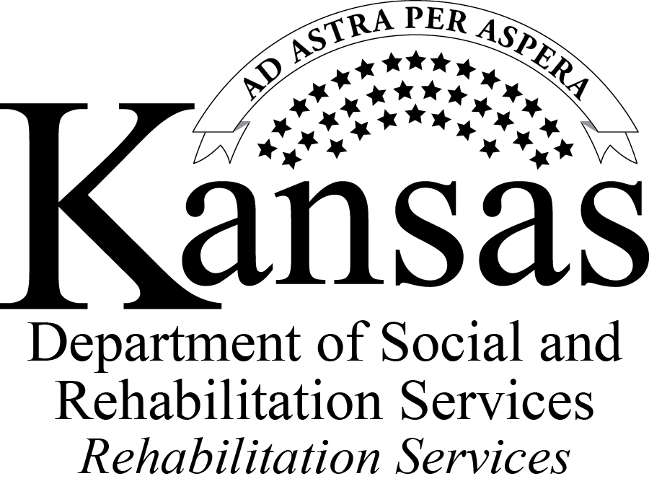

Questions and Answers Regarding the Request for Proposals (RFP)
Centers for Independent Living

INDEX BY TOPIC

Obtaining materials p. 2

Funding p. 2-3

Sustainability p. 3-4

Questions about the template or RFP instructions and application p. 4-6
Cover sheet p. 4
Gantt charts, logic models and timelines p. 4-5
Reporting guidelines p. 5
Clarification of RFP components and requested information p. 5-6

State Plan for Independent Living p. 7

Review process p. 7-8

Cross disability services p. 8

Obtaining materials
Question 1: Is there a way to obtain a copy of the PowerPoint slides from the pre-bid conference?

Answer 1: Please contact Brie Wilkins, SRS Procurement Officer, at brie.wilkins@srs.ks.gov to obtain a copy of the presentation.

Question 2: I was unable to access the Excel version of the attachments to the grant. Is there any way to do this?

Answer 2: Kansas Rehabilitation Services (KRS) posted a PDF version of these documents on the website. Persons wanting a copy of the Excel files may e-mail a request to Brie Wilkins, SRS Procurement Officer, at brie.wilkins@srs.ks.gov.

Funding
Question 3: In the Centers for Independent Living RFP it says the total award of $1.8 million is a combination of state and federal funds. What federal funds?

Answer 3: Funding for the State Independent Living Program totals $1.8 million and is comprised of both federal and state sources:
- State General Funds (SGF): State funds subject to Kansas legislative appropriation.
- Social Security Reimbursement (SSR): Federal vocational rehabilitation (VR) program income funds transferred from VR to the independent living program.
- Title VII Part B (State Independent Living Services Funds): Federal funds awarded by the Rehabilitation Services Administration (RSA) to states for the provision of independent living services.
Question 4: Is a cash match required? If so, how much cash match is required?

Answer 4: A cash match from applicants/grantees is not required. At the state level, Rehabilitation Act Title VII Part B funds require a 10% cash match of non-federal funds which come from State General Funds.

Question 5: How many grants/applicants will be funded?

Answer 5: The final number of grants to be awarded has not been determined. It is contingent on the applications received and providing the best coverage for the entire state.
Question 6: How will the existing funding of federally funded centers affect distribution of state funds?
Answer 6: Receipt of Federal Rehabilitation Act Title VII Part C funding, which is directly administered by RSA, will not affect the distribution of State Independent Living Program funds.

Question 7: On page 7 (under number 3) it states the total amount of state general funds and federal independent living funds that are available. However, how much are we supposed to ask for ourselves? Are we supposed to base it off what we received last year? We’re not sure how much of these funds we should be asking for at this point.

Answer 7: The amount listed on page 7 (number 3) reflects the entire pool of funding to cover the state. Applicants are encouraged to analyze the needs of the communities they propose to serve and develop a list of services they will provide. The budget should demonstrate how the funds will be used to provide these services and meet the community needs.

Sustainability
Question 8: On page 14 it asks about sustainability (i and ii). What are you looking for as far as cessation of grant funds? Are you wanting to know how we plan to fund ourselves without the grant? Also, could you explain point ii related to diversification of funding strategies at little more?

Answer 8: The RFP asks for applicants to detail how the project would continue if grant funded ended. Applicants should consider what services they would be able to continue to provide and at what level if grant funds were not available. Applicants should also identify the funding sources that would be used to continue these services, should such a situation occur.

Centers for Independent Living are mandated by the Code of Federal Regulations [34 CFR 366.50 (g)] to conduct resource development activities to obtain funding from sources other than Chapter 1 of Title VII of the Rehabilitation Act of 1973, as amended. Please describe any plans to diversify funding or methods and sources currently employed.

Question 9: This RFP asks about sustainability. Our center is providing a service to the state of Kansas. Should state funding cease we cannot guarantee that grant activities will continue. How should we address this in the RFP?

Answer 9: This section of the RFP is asking about how the center would manage any or all of the services if state funding were not available. Applicants should detail all methods of diversification of funds, and what, if any, services could continue if state program funds were no longer available.
Question 10: Does the inclusion of “sustainability” in the RFP reflect the probability that this funding source will end in three years?

Answer 10: No. Sustainability is considered to be good business practice and is directed through 34 CFR 366.60 (g).

Questions about the template or RFP instructions and application

Cover sheet
Question 11: Appendix B, Application for Grant Cover Page, asks for a grant number on the application template. How should this be filled in?

Answer 11: All entities applying for funding under this RFP should enter “Not Applicable” in this blank, regardless of whether or not they have previously received funding through the Independent Living Program.

Question 12: Appendix B, Application for Grant Cover Page asks for applicants to select new or continuation of funding. How should a Center for Independent Living that has previously received funds through the State Independent Living Program respond to this question?

Answer 12: All applicants should select “new award.”

Gantt charts, logic models and timelines
Question 13: The RFP Application Checklist refers to Gantt charts and logic models as attachments. What is this referring to?

Answer 13: Logic models and Gantt charts are optional attachments which are referenced in Part III, Proposal Requirements.
- Part III, Section 5, c, iv suggests that a Gantt chart may be used as a supplemental tool, and not counted as part of the narrative to explain project timelines.
- Part III, Section 5, b, ii suggests that a logic model may be used as a supplemental tool to describe the relationship between the issue, services that are provided and outputs and outcomes.
Question 14: In the project design, it mentions that an organization may provide a timeline. Is this for new Center for Independent Living (CIL) applicants only, or are there other timeframes that you expect to see?

Answer 14: A timeline should be provided for the development of new services.
Question 15: How is a Gantt chart appropriate for activities which have been implemented long ago and are offered on a continual basis?

Answer 15: A Gantt chart is not necessary for ongoing activities. A Gantt chart is offered as an optional tool to describe the implementation of any new service(s) or applications that propose to serve new areas of the state.

Reporting guidelines
Question 16: We have concerns regarding the 15th as the due date for reports. Is there a possibility of negotiation of those dates?

Answer 16: The reporting dates will be standard in all awards made under this RFP and will not be changed

Question 17: Can the due date for monthly reporting be changed from the 15th to the 25th?

Answer 17: No. The all awardees will be expected to provide reports within the established guidelines.

Clarification of RFP components and requested information
Question 18: What planning process are you referring to on page 13, item C, iv, b? There is not time to bring stakeholders together for input. Will the information gathered by stakeholders to create the current center three-year plan be sufficient?

Answer 18: This RFP was written to allow for new entities and existing centers to apply for funding. Applicants with existing three-year plans may provide a description of the process which they used to gather information from a pool of stakeholders in order to develop this strategic plan. If an applicant is an existing center and is proposing new services, any process used to assess community needs and decide on the service(s) to be delivered should also be detailed here. Please do not submit a copy of the strategic plan.

Question 19: What format do we use to demonstrate the “requirements of applicants” on page seven? For example: Section G related to hiring policies and procedures is requested in the narrative section, but is not listed on the application checklist. Should we include the actual policy as an attachment?

Answer 19: Please provide assurances and a brief description of relevant policies in your narrative. Do not submit policy manuals as an attachment.

Question 20: Are core services a sufficient “project” to include if that is all funds are used for? Or should other allowable independent living activities and a corresponding budget be provided to strengthen the application?

Answer 20: Applicants should determine the need for services within their communities. The applicant must determine if or when services other than the five core services will be provided. Be sure to include information that demonstrates your organization’s ability to deliver the services proposed.

Question 21: The RFP asks for a description of best or evidence-based practices. Our CIL uses the “self-determination model” and independent living philosophy as the foundation of our service delivery. Will a description of these satisfy the requirements of section 5d?

Answer 21: The terms self-determination model and independent living philosophy alone do not satisfy the requirements of this section of the proposal. Describe the key attributes of the best practice or evidence-based practices you intend to implement. Also describe how the model is known to be a best practice or is evidence-based and provide applicable citations, if any. Applicants should also detail how the model is being or will be implemented

Question 22: As a small agency we are concerned about an individual’s right to confidentiality. Can we provide a departmental list or chart which demonstrates compliance with staffing composition requirements?

Answer 22: Organizational charts do not need to detail personal information. They should detail position information. Be sure to demonstrate that, based on full-time equivalent (FTE) positions, your organization will meet the staffing requirements that 51% or more of management level staff are persons with a disability, and that 51% or more of all staff are persons with a disability.

Question 23: For the information requested in Attachment F, do you want us to list the previous fiscal years data from Oct. 2010 – Sept. 2011?

Answer 23: No. Attachment F is provided to applicants strictly for informational purposes related to reports that will be required of grantees.

Question 24: Is the RFP asking for signed board conflict of interest statements, or a blank copy of the form, or policy to illustrate its existence?

Answer 24: Either a policy or signed statements from board members will meet this requirement.

Question 25: Would online board training, such as training available through Independent Living Research Utilization (ILRU), meet the board training requirement?

Answer 25: Please provide a description of the training protocol and materials that will be used.
State Plan for Independent Living

Question 26: By opening up the RFP to allow a bidder to serve any county, are you indicating that KRS is not following the State Plan for Independent Living (SPIL)?

Answer 26: The State Plan for Independent Living serves as a planning document. It is not an assurance that any one or more organization will receive funds. For example, all program funds are appropriated by the Kansas Legislature. If Kansas experiences changes in appropriations, nothing requires the SPIL to be modified for federal approval.

Question 27: How will you ensure that the successful applicants are in compliance with the State Plan?

Answer 27: KRS will continue to cooperate with the Statewide Independent Living Council of Kansas (SILCK) to monitor, review, and evaluate the implementation of the State Plan, based upon their statutory duties. KRS will continue to provide monitoring reviews for all CILs.

Review process
Question 28: Who on the review team will have the technical expertise including knowledge of the Rehabilitation Act, the federal requirements of CILs and the federally approved State Plan for Independent Living?

Answer 28: The KRS representative facilitating the review panel will be Maia Ruby-Clemmons.

Question 29: I have heard the review team will be made up of SRS staff and one outside reviewer. Can you tell us who the outside reviewer will be and from where?

Answer 29: No.

Question 30: Will SILCK be providing technical assistance in the applicant review process?

Answer 30: KRS is not aware of the reviewers for this RFP at this time.

Question 31: When the Prairie Independent Living Resource Center (PILR) partnership wrote the RFP for the older blind (OIB) contract the instructions stated to send the budget and narrative in separate envelopes and on separate discs. This OIB RFP was also sent to the Department of Administration. I am curious why the IL RFP does not have to meet those guidelines? What has changed or is this RFP different in some way?

Answer 31: The older blind RFP was a negotiated procurement process resulting in CONTRACTS. Contracts, rather than grants, were required since this process
also included VR funding. RFPs resulting in contracts are processed through the Department of Administration.

On the other hand, the Center for Independent Living RFP will result in GRANTS. Grants are allowed in this instance because of the funding sources for this RFP. RFPs resulting in grants are processed through the Kansas Department of Social and Rehabilitation Services (SRS).

Cross disability service
Question 32: I am the Executive Director for American Sign Language Interpreter Connect (ASLIC) in the Kansas City area. ASLIC is a full-service sign language interpreting agency that also provides training.

I am in the process of working with a few key rural hospital systems in Missouri towards developing video remote interpreting (VRI) services with particular emphasis on supporting rural and underserved communities.

ASLIC has also been providing Deaf Education Substitute teachers with excellent success. I have access to tutors and language models available through our own specially tailored virtual classroom environment that is secure, private and requires no special equipment.

Although these developing services are not directly within the scope of the current RFP I am touching base with you to simply explore the potential for what is being currently developed. I believe that there exists an opportunity to collaborate in a way that can fill current gaps being experienced by rural communities, particularly through the leveraging of technology and specialized resources.

If you feel that the issue is worth exploring please feel free to touch base with me directly or simply refer as you feel would be helpful.

Answer 32: You are correct that the services you are providing are not in line with the scope of the current RFP in its requirement to provide services cross-disability (to persons with all types or classifications of disabilities).

Neither SRS nor KRS provide an endorsement of any provider of sign language interpreting services.

